ECE 310L: Microelectronic Circuits Lab

Lab 3: Diode Applications

Name:

Joe McCarver

Lab partner:

Changyu Guo

# Objectives

1. Learn the use of LTspice circuit simulator.
2. Investigate the performance of diodes in clipping and clamping circuits.
3. Understand the working mechanism of voltage multiplier. Use diodes and capacitors to construct a voltage multiplier circuit and investigate their performance.

# Background

## Clipping and Clamping Circuits

Due to the non-linear nature of diodes, we can use them to limit the voltage in a circuit to a set level. One very common use of this is in the suppression of electrostatic discharge (ESD) in circuits with connectors that are removed and inserted in use. Under dry conditions, a human body can easily store an electrostatic charge of 5−15 KV. If the person discharges into a circuit via the connector pins, semiconductor devices can be damaged or destroyed. To prevent this, we usually clamp the lines in question to one diode drop above the supply voltage and one diode drop below the supply voltage, as shown in Figure 1 for a typical USB data connection. On high-speed data lines, the diode junction capacitance must also be kept low to avoid corrupting the signals.



Figure 1. Clipping and Clamping Circuit

We can also use standard diodes and Zener diodes to prevent a signal from exceeding certain bounds, or only producing an output when bounds are exceeded. Both concepts are commonly used in practice.

## Voltage Multiplier Circuits

A voltage multiplier is a specialized rectifier circuit producing an output which is theoretically an integer times the AC peak input. For example, it is possible to get 200 VDC from an AC source of 100 V peak voltage using a doubler circuit, or 400 VDC with a quadruple circuit. Any load in a practical circuit will lower these voltages.

Voltage multipliers can be used to generate a few volts for electronic appliances, to millions of volts for purposes such as high-energy physics experiments and lightning safety testing. To understand the operation of voltage multiplier, we need to study a peak detection circuit.

### Peak Detector

A peak detector is a series connection of a diode and a capacitor outputting a DC voltage equal to the peak value of the applied AC signal. The circuit is shown in Fig. 2. An AC voltage source applied to the peak detector, charges the capacitor to the peak of the input. The diode conducts positive “half cycles,” charging the capacitor to the waveform peak. When the input waveform falls below the DC “peak” stored on the capacitor, the diode is reverse biased, blocking current flow from capacitor back to the source. Thus, the capacitor retains the peak value even as the waveform drops to zero.

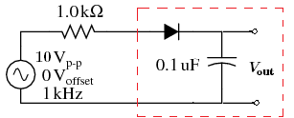

Figure 2. Peak detection circuit where diode conducts on positive half cycles charging capacitor to the peak voltage (less diode forward drop).

Figure 3 shows the output voltage waveform as a function of time for the peak detector. The input source is a sinusoidal function with a peak-to-peak amplitude of 10 V. The calculation starts the sine function on the negative phase. The circuit operates the same regardless the initial phase of the voltage source. However, it is easier to understand the operation of the peak detector with an initial negative phase. The output voltage builds up from 0 V to the maximum of 4.5 V after a few cycles. This is because it takes a few cycles for the capacitor to charge to the peak voltage due to the series resistance. The time constant of RC circuit about 0.1 ms, not short enough to charge the capacitor within a period (1 ms). The longer the RC constant, the more periods it takes to fully charge the capacitor to the peak voltage. The difference between the peak amplitude of the input source and the output voltage is due to the potential drop across the diode.





Figure 3. Output *V*OUT waveform as a function of time due to 10 Vp-p sinusoidal input power supply

LTspice circuit simulator provides a few built-in modeling diodes. The diode model is based on the characterization of individual devices as described in a product data sheet and manufacturing process characteristics not listed. If a diode is not included in the LTspice program, its SPICE model can typical be found from the manufacturer. For example, a rectifying diode 1N4004 has the properties shown in Fig. 4.

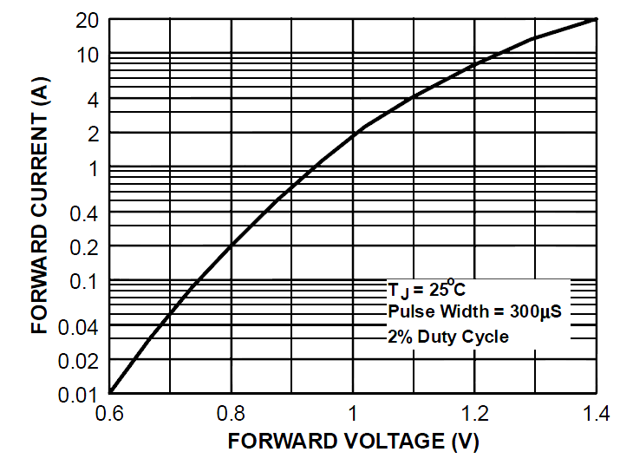 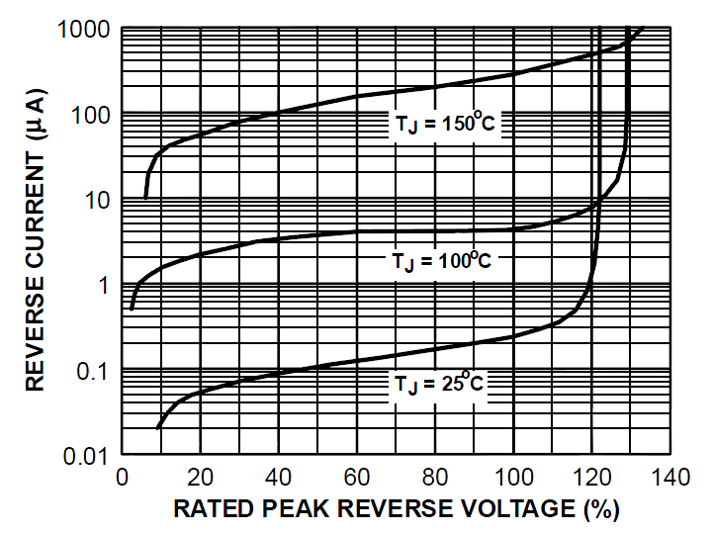

Figure 4. Forward (left) and reverse (right) *I*–*V* characteristics of a nominal 1N4004 rectifying diode.

A few important parameters are:

* Maximal average rectified current is 1 A
* Peak repetitive reverse voltage is 400 V
* Maximal reverse current at rated *V*R = 400 V is 5 µA at 25 °C

At diodes.com, SPICE model of 1N4004 can be found

*SRC=1N4004; DI_1N4004; Diodes; Si; 400V 1.00A 3.00us Diodes, Inc. diode

.MODEL DI_1N4004 D (IS=76.9p RS=42.0m BV=400 IBV=5.00u

+ CJO=39.8p M=0.333 N=1.45 TT=4.32u)

The model statement line begins with **.model**, followed by the model name matching one or more diode statements. This model file needs to be added into your SPICE model manually. The very first line is a comment that do not need to be added. The “+” sign at the beginning of the first line indicates that it continues from the previous line. It is a syntax to avoid writing extremely long lines. The model statement is a list of optional diode parameters in the form of **ParameterName** = **ParameterValue**, as listed in Table 1. For this course, you do not need to understand the meaning of all parameters.

Table 1. Typical diode SPICE parameters

|  |  |  |  |  |
| --- | --- | --- | --- | --- |
| Symbol | Name | Parameter | Units | Default |
| IS | IS | Saturation current (diode equation) | A | 1E-14 |
| RS | RS | Parasitic resistance (series resistance) | Ω | 0 |
| n | N | Emission coefficient, 1 to 2 | - | 1 |
| *τ*D | TT | Transit time | s | 0 |
| CD(0) | CJO | Zero-bias junction capacitance | F | 0 |
| φ0 | VJ | Junction potential | V | 1 |
| m | M | Junction grading coefficient | - | 0.5 |
| - | - | 0.33 for linearly graded junction | - | - |
| - | - | 0.5 for abrupt junction | - | - |
| Eg | EG | Activation energy: | eV | 1.11 |
| - | - | Si: 1.11 | - | - |
| - | - | Ge: 0.67 | - | - |
| - | - | Schottky: 0.69 | - | - |
| pi | XTI | *I*S temperature exponent | - | 3.0 |
| - | - | pn junction: 3.0 | - | - |
| - | - | Schottky: 2.0 | - | - |
| kf | KF | Flicker noise coefficient | - | 0 |
| af | AF | Flicker noise exponent | - | 1 |
| FC | FC | Forward bias depletion capacitance coefficient | - | 0.5 |
| BV | BV | Reverse breakdown voltage | V | ∞ |
| IBV | IBV | Reverse breakdown current | A | 1E-3 |

Another approach to incorporate manufacturer’s product is to use **.subckt** command. It is more command with MOSFET and BJT devices. We will encounter this in Lab 6: Buck Converter.

### Half-wave Voltage Multiplier

The half-wave voltage doubler in Fig. 5 is composed of two circuits: a clamper at (b) and peak detector (half-wave rectifier) in Figure 5c.

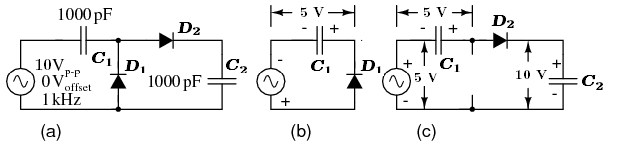

Figure 5. (a) Villard AC-DC voltage multiplier, a half-wave voltage doubler is composed of (b) a clamper and (c) a peak detector.

During the negative half cycle of AC input, *C*1 in Fig. 5b charges to 5 V (4.3 V considering the diode drop) on the. The right end is grounded by the conducting *D*1. The left end is charged at the negative peak of the AC input. This is the operation of the clamper.





Figure 6. Output *V*OUT waveform as a function of time due to 10 *V*p-p sinusoidal source showing the clamper and peak detection (half-wave rectifying) stage.

During the positive half cycle, the peak detector comes into play at Fig. 5c. Diode *D*1 is out of the circuit since it is reverse biased. *C*1 is now in series with the voltage source. Note the polarities of the generator and *C*1, series aiding. Thus, rectifier *D*2 sees a total of 10 V at the peak of the sine wave, 5 V from generator and 5 V from *C*1.

The circuit parameters used in the examples do not provide much current, usually in µAs. Furthermore, load resistors have been omitted. Loading reduces the voltages from those shown and increases voltage ripple. If the circuits are to be driven by a kHz source at low voltage, as in the examples, the capacitors are usually 0.1 to 1.0 µF so that milliamps of current are available at the output. If the multipliers are driven from 50/60 Hz, the capacitor are a few hundred to a few thousand microfarads to provide hundreds of milliamps of output current. When driven from line voltage (no transformer), attention must be paid to the polarity and voltage ratings of the capacitors. When constructing these circuits with electrolytic capacitors of any voltage, the capacitors will explode if the polarity is reversed.

### Cockcroft-Walton Voltage Multiplier

Villard half-wave doubler can be cascaded in arbitrary length to produce higher voltage multiples. Such circuit is known as a Cockcroft-Walton multiplier as shown in Figure 7. This multiplier is used when a high voltage at low current is required. The advantage over a conventional supply is that an expensive high voltage transformer is not required. Two of the doubler sections are cascaded to the right for a theoretical 4× multiplication factor. Node 1 has a clamper waveform, a sine wave shifted up by 1× (5 V). Node 2, the output of the first doubler, is a 2× DC voltage. Node 3 are sine waves clamped to successively higher voltages. Without diode drops, each doubler yields 2*V*in or 10 V. With the consideration of voltage drop across two diode, 10 – 1.4 = 8.6 V is more realistic. For a total of 2 doublers, one can expect 2 × 8.6 = 17.2 V.

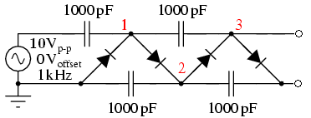

Figure 7. A cascaded Villard multiplier (Cockcroft-Walton multiplier) quadruples input voltage.

### Full-wave Voltage Multiplier

The circuit in Fig. 8 represents a DC power supply based on a half-wave rectifier. A larger “filter” capacitor would be used. A power supply based on a 60 Hz source with a filter of a few hundred µF could supply up to 100 mA. Half-wave supplies seldom supply more due to the difficulty of filtering a half-wave.

The full-wave voltage doubler is composed of a pair of series stacked half-wave rectifiers, as shown in Fig. 8. The bottom rectifier charges *C*1 on the negative half cycle of input. The top rectifier charges *C*2 on the positive half-cycle. Each capacitor takes on a charge of 5 V (4.3 V considering diode drop). The output is the series total voltage across *C*1 and *C*2, or 10 V (8.6 V with diode drops).

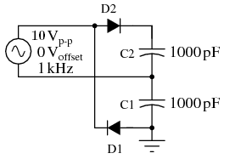

Figure 8. Delon AC-DC voltage multiplier, a full-wave voltage doubler consists of two half-wave rectifiers operating on alternating polarities.

Figure 9 illustrates the derivation of the full-wave doubler from a pair of opposite polarity half-wave rectifiers in Fig. 9a. The negative rectifier of the pair is redrawn for clarity, as in Fig. 9b. Both halves are combined in Fig. 9c sharing the same ground. At Fig. 9d, the negative rectifier is re-wired to share one voltage source with the positive rectifier. This yields a ±5 V (4.3 V with diode drop) power supply. In total, 10 V is measurable between the two outputs. The ground reference point is moved so that +10 V is available with respect to ground.

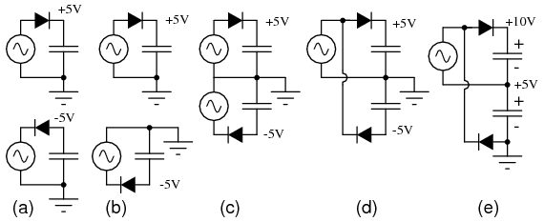

Figure 9. The formation of full-wave Delon AC-DC voltage doubler: (a) a pair of doublers, (b) redrawn, (c) sharing the ground, (d) share the same voltage source. (e) move the ground point.

# Materials

* DMM, Agilent E3631A
* Signal generator, Agilent 33220A
* Oscilloscope, Agilent DSO5014A
* Solderless breadboad
* Hookup wires
* Assorted resistors: 100Ω (100.35 Ω), 1 KΩ (1.022 KΩ), and 10 KΩ (9.9875 KΩ)
* Capacitors: 330 nF
* Assorted diodes: 1N4004, 1N4148, 1N5230B, 1N5817

# Pre-lab Assignments

Question 1. Draw schematic diagrams for four diode circuits that will meet the criteria given below for a circuit type as shown in Figure 4, where the square represents the diode circuit arrangement you will design. (If you cannot meet the criteria below exactly, meet them as closely as possible.) You can use any number of 1N4004 diode and 1N5230B Zener diode. Assume the constant voltage drop (CVD) models with 1N4004 *V*D,on= 0.6 V, *V*R = 400 V and 1N5230B *V*D,on= 0.8 V, *V*Z = 4.7 V. Your circuits must have no other connections other than the 3 connections shown.

1. Circuit 1: No output should be outside the range [−4.7 V, +0.8 V]
2. Circuit 2: No output should be outside the range [−4.7 V, +0.6 V]
3. Circuit 3: No output should be more positive than approximately +6 V
4. Circuit 4: No output should be outside the range [−0.6 V, +5.5 V]

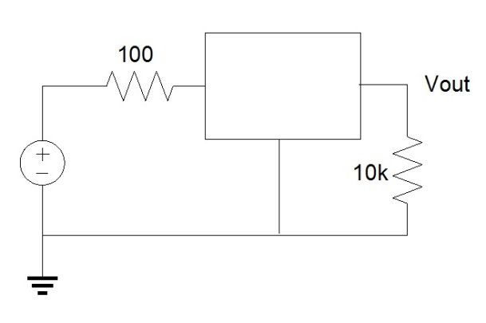

Figure 10. Clamping and Clipping Circuit

for part b both diodes are forward biased

for part c two opposing Zener parallel with 1 normal diode, parallel with the load (third image is actually for part d)

Question 2. For the voltage multiplier circuit shown in Figure 11, the ideal voltage source produces a 5 Vp-p sinusoid at 10 KHz. The diodes are 1N4004 and the capacitance is 0.1 µF. Analyze the performance of the circuit with LT SPICE. Start the source at 0 V at *t* = 0 and goes to the negative half-cycle. Show *V*S and *V*OUT as a function of time from *t* = 0 until steady state is reached.

What do you expect the steady-state *V*out to be? What effect would adding a 100 KΩ load resistance from *V*OUT to ground have on the output?

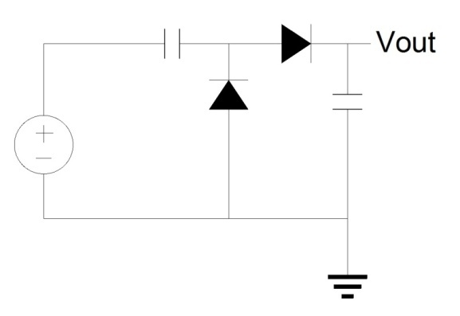

Figure 11. Voltage Multiplier Circuit

Question 3. Charge Pump

The same principle of utilizing capacitors as energy storage elements to create a higher output voltage can also be applied to DC source. Such circuit is called charge pump. It is a DC-DC converter that uses switching circuit to control the connection of voltages to the capacitor. Charge pump circuit are capable of high efficiencies, sometimes as high as 95%.

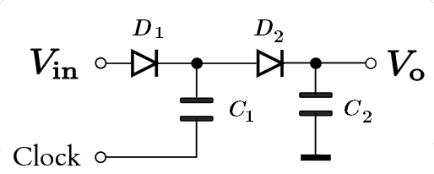

Figure 12. DC-DC voltage doubler circuit using a rectangular wave as a clock signal.

Figure 12 shows a DC-DC doubler circuit using a clock pulse trains with an amplitude swing between the DC supply rails. Use LT SPICE to model the circuit assuming *V*in = 5 V and the clock produces a 1 KHz square wave with low of 0 V and high of *V*in. Explain how the charge pump works.

# Setup

Turn on power to the DMM, oscilloscope, and signal generator.

# Lab Assignments

1. Construct each of the circuits you designed for the Question 1 of the pre-lab assignments. Use a 20 Vp-p sinusoid as the input voltage, verify the operation of each circuit. Plot waveforms of all circuits below. In the plot, overlay the output with the input waveforms, distinguishing the two curves by color.
2. How does the performance of each clamping circuit (Lab Assignment 1) compare to what was expected (Pre-Lab Assignment 1)? What could account for any differences?
3. Construct the circuit shown in Figure 3. Use 1N4004 diodes and 330 nF ceramic capacitors. Set the signal generator to produce a 5 Vp-p sinusoid at 10 KHz. Measure the circuit’s performance (*v*avg, *v*ripple) under no load and when loaded with a 10 KΩ resistor. Record the values in Table 3.
4. Replace the diodes 1N4004 with 1N5817. How do they affect the loaded and unloaded performance? Record the values in Table 3.

Table 3. Measured Multiplier Circuit Performance under Load

|  |  |  |  |  |
| --- | --- | --- | --- | --- |
| Measurement | 1N4004 | | 1N5817 | |
| No load | 10 KΩ | No load | 10 KΩ |
| *v*avg (V) |  |  |  |  |
| *v*ripple (V) |  |  |  |  |

# Discussion

1. Conduct a literal review and list 2-3 applications where a voltage multiplier circuit can be used?

2. What characteristic(s) of the 1N5817 diodes accounts for the difference between Lab Assignments 3 and 4?